KS4 Latin teacher survey
Data collected Summer 2017

Contents
Summary of Findings 2
Teaching Context 2
Qualifications 2
The CLC 2
Training Needs 3
Full Analysis and Narrative 4
Teaching Context 4
School and Teacher Types 4
Hours of Latin Taught 5
Cohort Size 5
Qualifications 7
The Cambridge Latin Course 10
CSCP Resources 15
Training and Resource Needs 15

Summary of Findings
There were 266 respondents. We can see from the post code gathering that only a few are duplications from one department, and so general trends can safely be assumed to not be skewed.
Responses were received from independent : state schools in the ratio c. 60:40.

Teaching Context
- 33% of teachers in the state sector are non-specialists, as opposed to just 1.4% of those in the independent sector.
- In both state and independent sectors the majority of students at KS3 receive 1-2 hours of Latin a week, and those at KS4 2-3 hours, however:
  - at KS4 there are more Independent than State schools giving 3-4 hours of Latin a week, and the percentage of those doing just 1-2 hours at KS4 is much higher in the State sector than the independent.
  - Only 3% of state respondents have less than an hour a week at KS4, but this is in contrast to the Independent sector, where this is almost unheard of.
  - 1-2 hours at KS4 is highly unlikely in the independent sector, as opposed to the state sector where around a quarter of teachers have just 1-2 hours a week with students.
- In the State sector 42% of schools do not have Latin in Year 7, and 25% don’t have it in Year 8; it is introduced further up the school. This model is much more unusual in the independent sector.
- This implies that most state school students and teachers have not just fewer hours, but also fewer years of study in which to prepare students for KS4.
- 84.96% of Latin hours in the UK are taught ‘on timetable’. However, the likelihood of being taught ‘off timetable’ rises significantly if one is in the state sector (24.27%) than in the Independent (3.4%).
- Sector does not seem to have an impact on cohort size.

Qualifications
- OCR retains its lead when looking at the GCSE market as a whole, but in the state school sector Eduqas has developed a narrow lead. The WJEC Certificates are used more by the state sector than the independent.
- The Eduqas Certificates and GCSE are more popular with non-specialists teachers. OCR is much more popular with specialist teachers. This could imply that Eduqas qualifications are well suited to new teachers of the subject, and OCR to those with more confidence or experience.
- In cases where teachers have less than 2 hours’ teaching time in Year 11, it becomes more likely that the Certificates will be offered, not a GCSE. Therefore, support for Eduqas’ Certificates is crucial to support teachers on truncated timetables and ensure Latin remains accessible.

The CLC
- Pattern of usage is approximately the same across sectors.
- The vast majority of schools use the CLC at some point, however, 74.49% of those who use the CLC do not use all five books.
- Whilst the CLC is used extensively in teaching early Latin its usage drops off strikingly in the later stages. Book 1 is very popular, and then popularity decreases as you progress through the books (just 2 respondents use Book 5).
- Time constraints are the most commonly asserted reason for not using the (full) course.
- The second most commonly cited reason for not using the whole CLC course, is that the CLC does not prepare students adequately for KS4 exams. This is third cited reason for those who don’t use the course at all.
- The percentage of people who feel the course isn’t suitable for KS4 qualifications drops considerably (to 24.19%) if one filters for those taking GCSE with Eduqas, and even further (22.5%) if they are taking the Certificates. Implying that either the CLC is inherently better suited to teaching of the Eduqas qualifications than OCR, or that the support available for Eduqas teachers has enabled them to more effectively use the CLC in their teaching.
- Most teachers who use the CLC, even those who use all the books, do not use them as their only teaching tool. 86.44% of teachers are having to do extensive extra work to support the textbook with in house resources.
- Of those who answered ‘I prefer to use a different textbook’ 100% of them use Latin to GCSE by John Taylor, and no other textbooks. This group also shows a significantly lower use of Books 3 and 4. Implying that there has been a shift to using the Taylor at the expense of Books 3, 4, and 5.
- Teachers who don’t use the CLC at all primarily make use of Latin to GCSE by Taylor and Cullen and/or resources produced in house.
- The vast majority of teachers who no longer use CLC have done so in the past. Reasons for changing are varied, but it is interesting to note that the three who cite a ‘new textbook’ as the reason are all Taylor users.
- The survey also asked evaluative questions regarding the best and worst things about using the CLC. Trends and common answers can be identified and are listed on page 13.

Training Needs
Filtered for state school only as this is CSCP’s primary remit.
- On the whole teachers are ‘somewhat confident’ with teaching the GCSE (9-1), no one is expressing ‘no confidence’.
- The vast majority of teachers appear to be confident with the language element of the GCSE.
- Literature, Sources and Exam Technique all seem to be of equal concern and comfort. Many people appear confident in these areas, but a significant minority appear to have concerns.
- Respondents were also asked to rank these areas of teaching in terms of need for resourcing and training; 1 being the greatest need, 4 the lowest. Collated ranking:
- Literature
- Exam Technique
- Language / Culture

Full Analysis and Narrative

Teaching Context

School and Teacher Types
Responses were received from independent – state schools in the ratio c. 60-40, which is an excellent rate given the dominance of the independent sector in Latin.
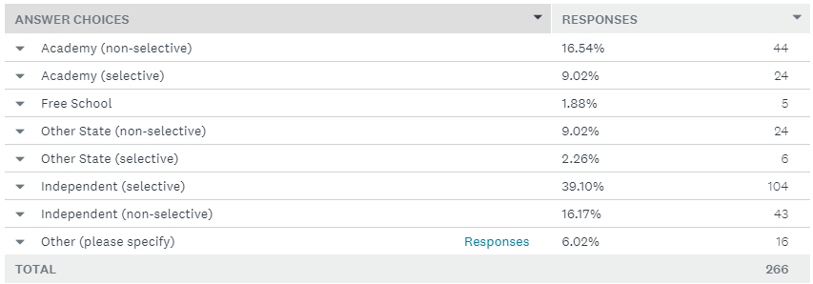
It is also interesting to note that the state responses are not dominated by selective schools.
Analysis has been undertaken both of all responses and those specifically of state school teachers. Although the focus of the Project is on state schools, the responses of the independent sector are still valuable for understanding the how Latin is taught.
Of those who responded, the vast majority were specialist teachers, both in the state and independent sectors.
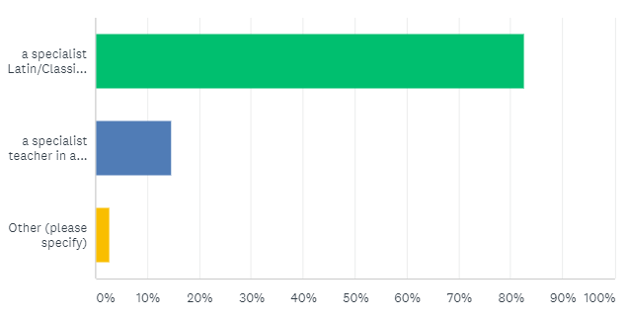
Of the 39 non specialists who responded only 2 were in independent schools. Whereas in State Schools 33% of the teachers surveyed were non specialist:
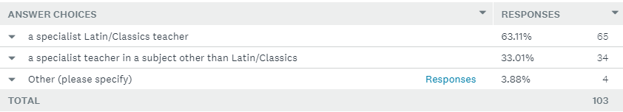

Hours of Latin Taught
The amount of hours that Latin is taught varies across school year groups and school types, but there are trends which can be observed.
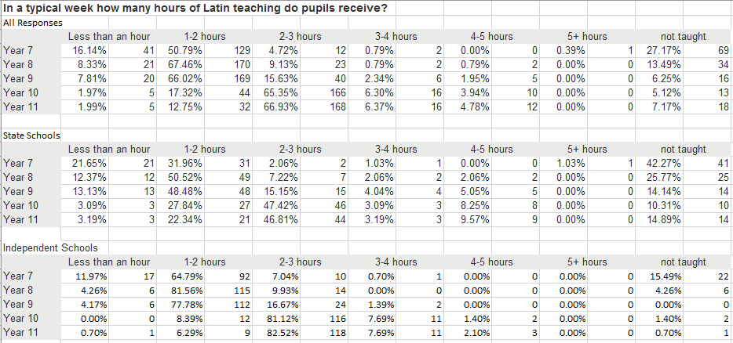
The majority of students at KS3 receive 1-2 hours of Latin a week, and those at KS4 2-3 hours in all sectors. The vast majority of independent schools (c. 80%) have 2-3 hours a week with KS4 students and over an hour at KS3. In the state sector the picture is more varied, and it is far more likely that Latin will be being taught with far less contact time.
The percentage of those doing 1-2 hours at KS4 is much higher in the State sector than the independent and there are more Independent than State schools giving 3-4 hours of Latin a week.
Interestingly the very high outliers (over 4 hours a week) are more State dominated. This could be evidence that Latin is introduced later in these schools and studied more intensively.
The percentage of schools working with less than an hour is higher in the state sector. Only 3% of state respondents have less than an hour a week at KS4, but this is in contrast to the Independent sector, where this is almost unheard of. 1-2 hours at KS4 is also highly unlikely in the independent sector, as opposed to the state sector where around a quarter of teachers have just 1-2 hours a week with students.
In the State sector 42% of schools do not have Latin in Year 7, and 25% don’t have it in Year 8; it is introduced further up the school. This model is much more unusual in the independent sector.
All this implies that most state school students and teachers have not just fewer hours, but also fewer years of study in which to prepare students for KS4.
Most Latin hours in the UK are taught ‘on timetable’ (84.96%) across all sectors. However, the likelihood of being taught ‘off timetable’ rises significantly if one is in the state sector (24.27%) than in the Independent (3.4%).

Cohort Size
Teachers were asked about their average KS4 cohort size, and responded as follows:
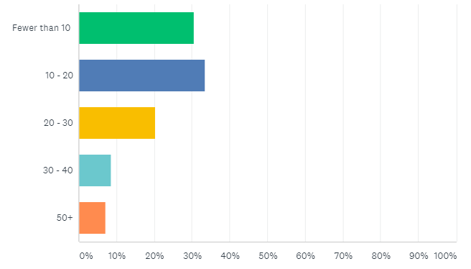
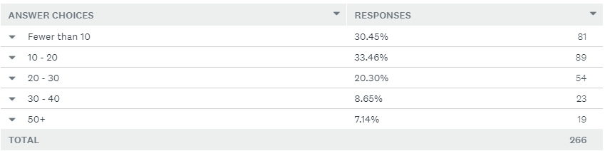
Interesting the pattern of remains almost identical when we look only at state school responses or only at independent schools. So we can assert that sector doesn’t have a big impact on cohort size and distribution at KS4. Once Latin is established it attracts approximately the same amount of students whether you are in the state or independent sector. Although if taken as a percentage of the whole school cohort, the proportion taking it in the state sector might well be lower than the independent.

Qualifications
As anticipated OCR retains its lead in the GCSE market, but in the state school sector Eduqas has developed a narrow lead. The WJEC certificates are also used more by the state sector than the independent. Interestingly however, the percentage of state schools using OCR is not inconsiderable and so clearly should not be discounted.
All respondents:
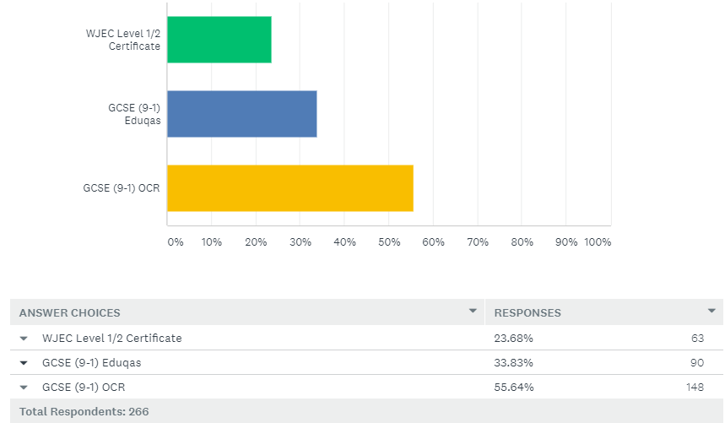
State Schools:
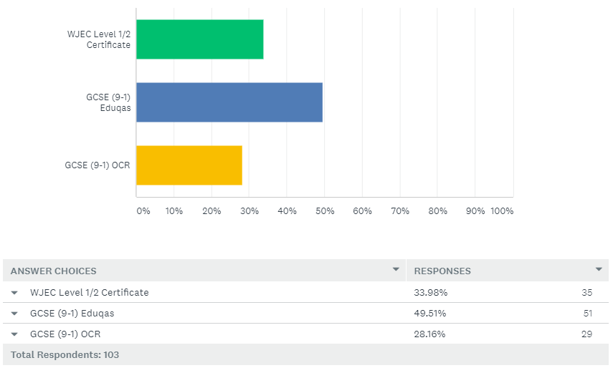
Independent Schools:
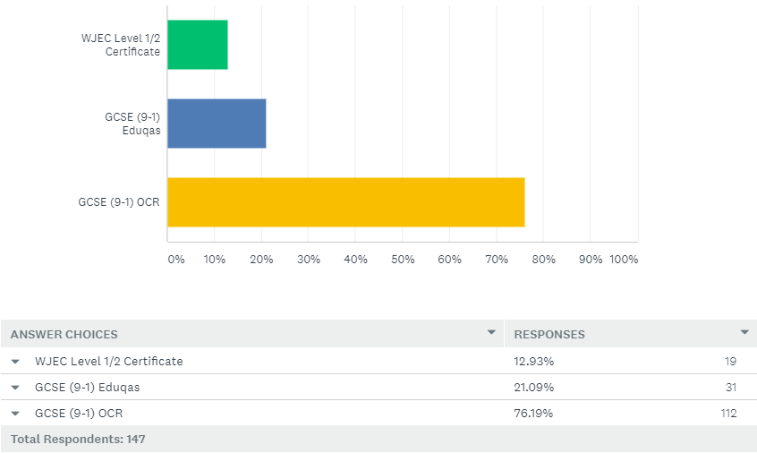
When one filters for ‘specialist’ and ‘non specialist teachers’ however, we an even more dramatic pattern:
Non-Specialist:
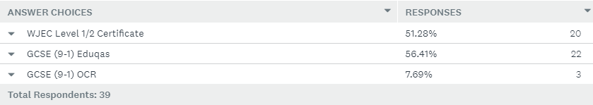
Specialist:
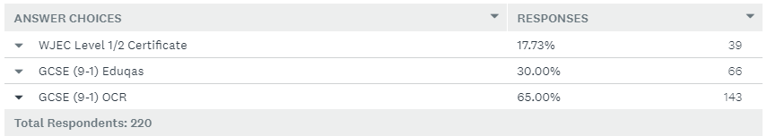
As can be seen, the vast majority of non specialists use Educas’ Certificates and the Eduqas GCSE. The OCR qualification is used by a very small proportion of these teachers, and is much more popular with specialist teachers.
This implies that Eduqas’ qualifications are well suited to new teachers of the subject, whereas OCR is better suited to those with more confidence or experience. However, it is worth considering that the recent CSCP initiative with the DfE focused on training non-specialist teachers of Latin working with over 200 teachers. These teachers would have undergone training specifically using the Eduqas qualifications, and so this may have skewed the selection of qualifications.
If we filter for responses which say they have 2 hours or less teaching time in Year 11, then we get the following distribution:
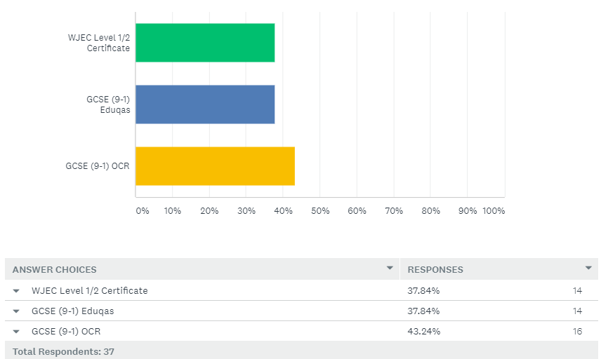
If this is compared to the totals for all respondents, then it can be seen that the distribution seems to be slightly more in favour of Eduqas, but this is not a dramatic shift (just a 4.01% shift in Eduqas’ favour). The percentage using OCR drops by 12.4%, and that using the Certificates increases by 14.16%.
This data implies that if teaching time is under 2 hours it becomes more likely that the Certificates will be offered, not the GCSE, implying that they are considered to be the most appropriate option for a truncated timetable. Eduqas and OCR appear to be pretty similar in terms of the suitability of their GCSE.
This emphasises the need to support the Eduqas certificates to support teachers on truncated timetables and ensure Latin remains accessible.

The Cambridge Latin Course

Respondents were asked whether or not they used the Cambridge Latin Course. As the following demonstrates, the majority of schools do use it, but a significant amount do not use it throughout KS3 and 4.
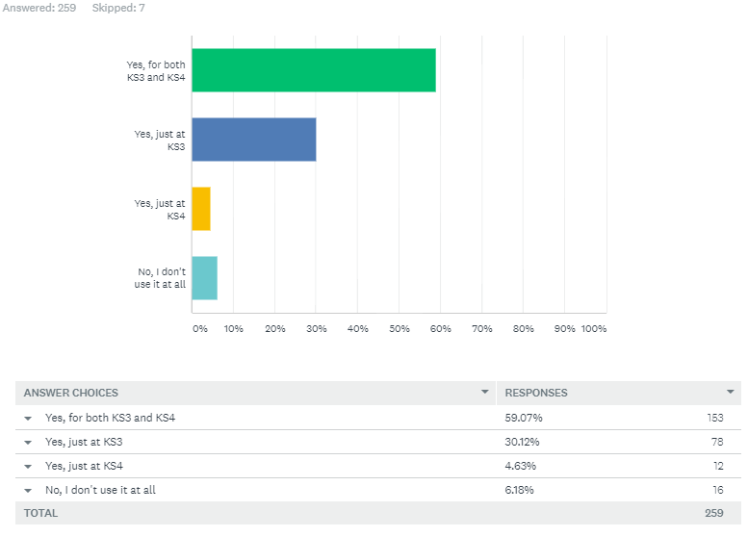
This distribution (and that of other questions in this section) is almost identical if one filters by state schools only, so usage is approximately the same across sectors.
74.49% of those who use the CLC do not use all five books. The distribution of book usage closely reflects the sales figures of CSCP’s royalty reports, meaning we can be very confident that this is representative:
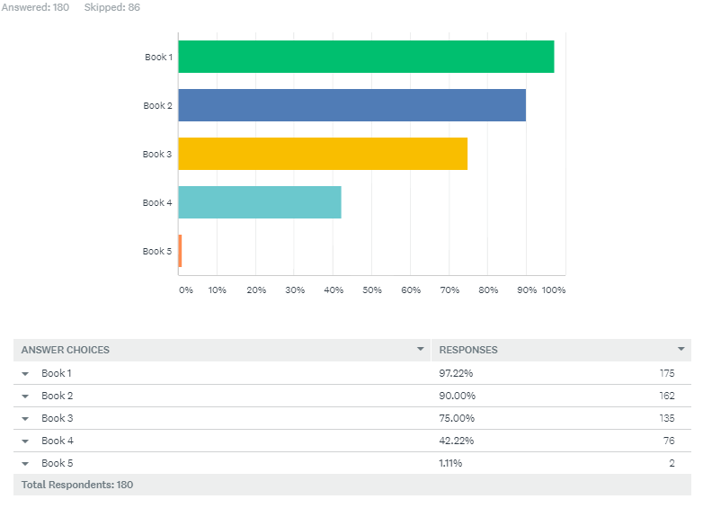
This shows that whilst the CLC is used extensively in teaching early Latin (Books 1 and 2 are especially popular) its usage drops off strikingly in the later stages. This is especially concerning given the volume of crucial concepts and grammar needed for KS4 in Book 4.
Respondents were then asked why they don’t use all five books of the CLC:
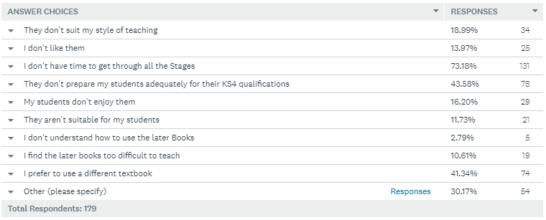

This pattern of reasons is reflected in the responses from teachers who don’t use the CLC at all:
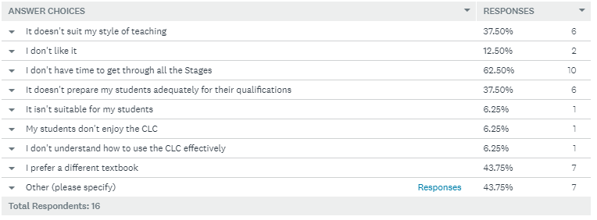
In both sets of data, the most commonly asserted reason for not using the (full) course is lack of time to get through all the stages.
The second most commonly cited reason for those only partially using the CLC is that it does not prepare students adequately for KS4 exams. This is third for those who don’t use it at all. In addition to those who selected this option, it’s worth looking at the 54 people who gave ‘Other’ responses for the first set. 17 of the 53 state that they feel Book 5 goes beyond what is needed for GCSE standard, and 5 others comments that the teaching style they think is required for GCSE study is not compatible with the CLC.
Of those who answered ‘I prefer to use a different textbook’ 100% of them use Latin to GCSE by John Taylor, and no other textbooks. This group also shows a significantly lower use of Books 3 and 4. Implying that there has been a shift to using the Taylor at the expense of Books 3, 4, and 5.
Interestingly, the percentage of people who feel the course isn’t suitable for KS4 qualifications drops considerably (to 24.19%) if one filters for those taking GCSE with Eduqas, and even further (22.5%) if they are taking the Certificates. Implying that either the CLC is inherently better suited to teaching of the Eduqas qualifications than OCR, or that the support available for Eduqas teachers has enabled them to more effectively use the CLC in their teaching.
Most teachers who use the CLC, even those who use all the books, do not use them as their only teaching tool: 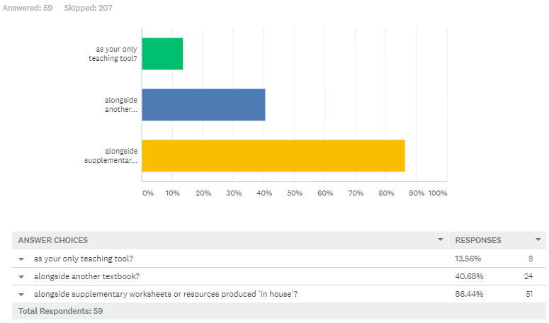
The percentage of those using extra resources does not change if one filters for those who use all the books of the CLC. This implies that the CLC is not considered sufficient on its own and that 86.44% of teachers are having to do extensive extra work to support the textbook with in house resources.
The survey also asked evaluative questions regarding the best and worst things about using the CLC. Whilst these require more in-depth analysis, trends and common answers can be identified.
Best things about the CLC? | Hardest or worst things about the CLC?
Overwhelmingly most common answer is praise of the storylines  Online activities and supplementary resources  Clear progression through the books  Mix of language and culture  Integration of grammar and stories | Mismatch with GCSE vocabulary and grammar  Prefer a teaching style that tackles ideas as a whole, not piecemeal  Issues of teaching with limited teaching time  Requires production of supplementary material  Some stories too long and hard to get through  Grammar order of introduction isn’t very intuitive  Issues with differentiation  Cost of books

Teachers who don’t use the CLC at all primarily make use of Latin to GCSE by Taylor and Cullen and/or resources produced in house.
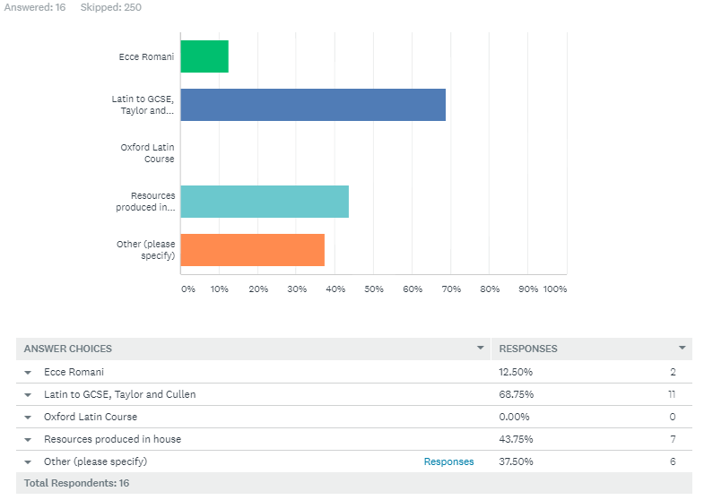
Most of the comments in favour of these alternatives centre on the ability to teach grammar quickly and in a focused manner, most criticisms lament the absence of engaging storylines and culture elements.
As mentioned above, these teachers also mostly cite a lack of time as the major factor for not using the CLC, and also issues surrounding suitability for GCSE (as in the previous similar question many of the ‘Other’ comments reference GCSE issues). Again many prefer a different textbook, and again this textbook is universally the Taylor and Cullen; showing its impact on the market.
The majority (86.5%) of teachers who now don’t use the CLC, have done so previously. The reasons for doing so are as follows:
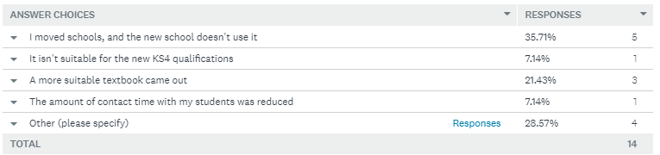
For five, therefore, stopping use of the CLC was not a personal decision but an institutional one; a new school simply used something else. For one person a reduction in contact time caused a switch, and for another the new KS4 qualifications. The ‘Other’ responses say they prefer a more grammatically focused course, and also have issues of accessibility and differentiation. Three respondents changed to a new textbook, all of these now use the Taylor/Cullen.

CSCP Resources
Teachers were asked which of the CSCP resources they made use of. The percentages and trends remain the same if you filter for state schools, so using the overall data is reasonable.
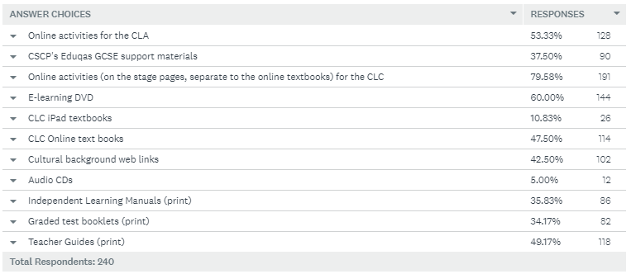
The online materials are very useful to teachers clearly, which supports creation of further digital materials. The E-Learning DVD is also well used and clearly a key material. Whilst the print materials are less used, a significant number of teachers use each of them. The least used is the CD by a long way, which implies that either the format or material contained on it, might be out of date.

Training and Resource Needs
Finally, teachers were asked about their confidence with the new KS4 qualifications and to rank their needs for training and new resources.
For the analysis here, I have filtered for state school responses as thuese are our target customers.
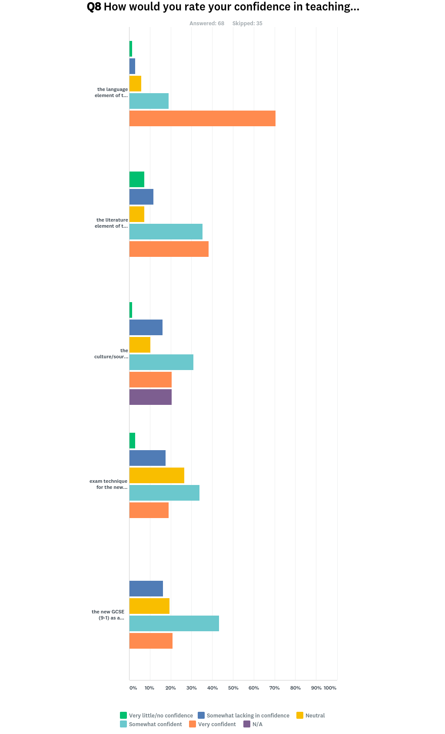
As can be seen from these charts on the whole teachers are ‘somewhat confident’ with teaching the GCSE (9-1), no one is expressing ‘no confidence’ which is excellent news.
The vast majority of teachers appear to be confident with the language element of the GCSE.
Literature, Sources and Exam Technique all seem to be of equal concern and comfort. Many people appear confident in these areas, but a significant minority appear to have concerns.
Respondents were also asked to rank these areas of teaching in terms of need for resourcing and training; 1 being the greatest need, 4 the lowest.
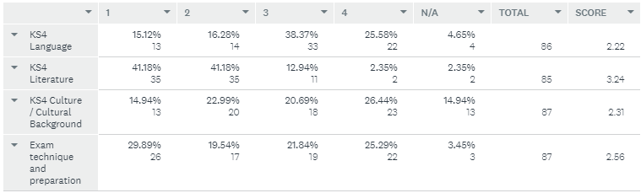
From these figures, we can rank these areas as follows:
- Literature
- Exam Technique
- Language / Culture
We also gave a free text opportunity for people to make suggestions. Of those offered by the state school respondents, the following ideas are of note:
- Literature for those tight on time
- Learning vocabulary and grammar in a manageable way
- How to tie the CLC to the GCSE more closely
- Practice papers and exemplar essays
- OCR sources / Eduqas civilisation textbook
- OCR suggested translations
- Exercises to help teach students’ literary analysis
- Literature resources for CLA texts (also a comment about the need for CSCP to be less territorial about these!)
- Teaching SEN students not just G&T
- Scaffolding for skills acquisition
- More courses available in a wider geographical range
- Online CPD
- Assessment resources for in-school assessments
- English into Latin
- Training specifically for non-specialist teachers
- Unseen translation/comprehension materials

